*P210/3*

*History*

*(EUROPEAN HISTORY)*

*Paper 3*

*MAY-JUNE-2023*

*3 hours*

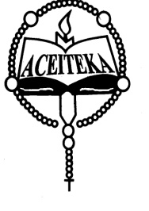

**ACEITEKA JOINT MOCK EXAMINATIONS 2023**

**UGANDA ADVANCED CERTIFICATE OF EDUCATION**

**HISTORY**

**(EUROPEAN HISTORY 1789 – 1970)**

**3 HOURS**

**Instructions:**

Answer FOUR questions only.

All questions carry equal marks

Any additional questions attempted will not be marked.

1. Account for European hostility against France in the period 1792 to 1814

(25 marks)

1. “The violation of the 1814 constitutional charter was primary responsible for the collapse of the restored Bourbon Monarchy in France in 1830” Discuss.

(25 marks)

1. How was Prince Metternich able to dominate Europe in the period of 1815 to 1845? (25 marks)
2. Explain the process of German unification between 1850 and 1871.

(25 marks)

1. Examine the causes and consequences the Greek war of independence.

(25 marks)

1. To what extent was Serbia responsible for the 1914 – 1918 World catastrophe? (25 marks)
2. How did the Versailles peace treaty of 1919 undermine European peace between 1919 and 1939? (25 marks)
3. Account for the survival of Fascism in Italy up to 1944 (25 marks)
4. Assess the role of Adolph Hitler in the outbreak of World War II.

(25 marks)

1. How successful was the United Nations Organization up to 1970?

***END***